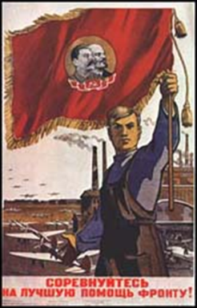N

**EFFECTS OF WWI**

* **_______ignored signs**
* **Seen as __________ and ______**
* **Did not see that __________ were needed.**

**REFLECTION: Czar-Love him or List him?**

SS6H7(a) Describe major developments after WWI: The Russian Revolution

Name: ______________________________

**RUSSIAN**

**REVOLUTION**

**BLOODY SUNDAY**

* **1905- LOST WAR WITH ________**
* **Angered ___________ and _________________**
* **March to palace to ask for ____________(changes)**
* **Troops shot into the ____________**
* **More ____________ afterwards**

**THINKING LIKE A HISTORIAN**

**Photo One:**

**Photo Two:**

**EFFECTS OF World War I**

* **1914-Russia enters war**
* **Millions ______, ________ or ___________**
* **People suffered ____________**
* **Soldiers did not have enough _____________________, ______________ or _________________**

**PRE-REVOLUTION RUSSIA**

* **Only true ___________ (single ruler) country in Europe**
* **_____________ last ___________ of Russia**
* **_____________ ___________ anointed (chosen) by _______**

**One thing I observed:**

**RUSSIA’S SERFS**

* **_____ ______ (serfs)**
* **__________ _______=**

**______ ________ _____, a tiny piece of _______, and a few ___________**

* **Most crops went to the landlords as _______________**
* **Resist and be ________!**

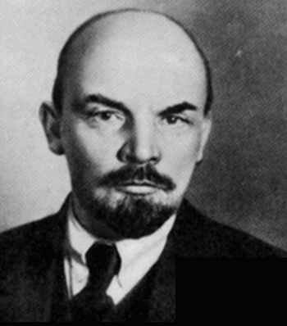

**REVOLUTION!**

**3 notes from the video clip:**

**1.**

**2.**

**3.**

**WHY COMMUNISM??**

* **_______________________ should own ____________ and _______________ to benefit _________ citizens**
* **__________ _________________ = ________________ ________________**
* **Promised that ___________________ and _______________________ would come to ____________ Russians**

**LENIN**

* **1917: ____________ took control of the _________government**

**The Czar and his family were _____________**

* **1922: Russia reorganized and named ___________ __________**

**COMMUNISM COMES TO RUSSIA**

* **1917: _________ in the street**
* **Women, factory workers and _______ demanded _________**
* **Citizens outnumbered by _________ and ______**
* **Czar force to give up _____**
* **A ____________ government took over**