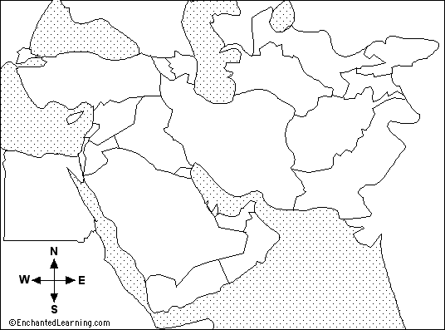
Iraq
Kuwait
The Persian Gulf War

Iraq underwent one political upheaval after another in the
late 1960s and 1970s, until 1979, when Saddam Hussein came to power.
Almost immediately, Iran and Iraq fought a devastating war that gained
neither country any territory but cost a total of 1 million lives lost.
The war ended in 1988.

For many years, Iraq and Kuwait had disputed parts of the border between their two countries. The territory near the border is desert-like, for the most part, and desert winds whip sand around until borders can hardly be seen for sure.

In 1990, Iraq accused Kuwait of drilling for oil in disputed lands. The places that Kuwait was drilling might very well be Iraqi land, Iraq argued. Kuwait argued that it was drilling in Kuwaiti territory. Both countries traded charges and countercharges, and diplomacy didn't work anymore. Iraqi troops invaded Kuwait and quickly overran the country, on August 2.

With the Iraqi occupation of Kuwait, Saudi Arabia and other countries in the Middle East worried that Iraq wouldn't stop there but would invade other countries as well. The United States and other countries made it very clear that what Iraq had done was invade another independent country and take it over. The United Nations Security Council condemned the Iraqi invasion and imposed an embargo that made illegal almost all trade by any other country with Iraq. Iraq responded by claiming Kuwait as the 19th Province of Iraq.

The United Nations and a great many other countries were angered. The U.N. Security Council adopted sanctions (economic punishment) against Iraq, but Iraqi troops still patrolled Kuwait. Finally, in November 1990, a U.N. resolution allowed other countries to use any means necessary (including military action) to convince Iraq to leave Kuwait.

For weeks, members of the armed forces of many countries from around the world had been gathering in Saudi Arabia. The initial idea was to protect that country and others around it from further Iraqi aggression. But the more Iraq refused to cooperate, the more these Allied troops turned their thoughts from defense to attack.

Iraq had a deadline: January 15, 1991. That day came and went, and Iraqi troops still patrolled Kuwait. Two days later, Allied forces from 28 countries struck back.

The war lasted six weeks, during which the Allies hit Iraq with 140,000 tons of bombs (more than 7 Atomic bombs). About 20,000 Iraqi soldiers were killed, and about 2,300 Iraqi civilians died as well. Allied deaths numbered in the hundreds.

On February 28, 1991, a cease-fire was announced. Iraq agreed to give up its claims to Kuwait. Iraqi troops quickly left Kuwait. Included in the agreement was a promise by Iraq that it would allow international weapons inspectors to tour weapons factories at regular intervals, to make sure that Iraq wasn't making more and more weapons like the chemical weapons that they used on their own people in 1988.

http://www.socialstudiesforkids.com/articles/worldhistory/thegulfwar2.htm

