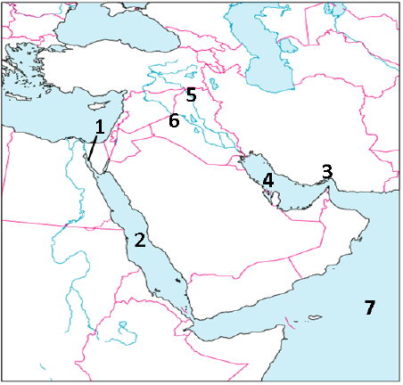

- Identify the physical features numbered in the diagram to the right. (SS7G5a)
1: ______________________________
2: ______________________________
3: ______________________________
4: ______________________________
5: ______________________________
6: ______________________________
7: ______________________________
8: ______________________________

8

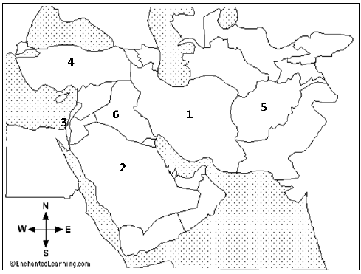
- Identify the Southwest Asian countries numbered on the map to the right. (SS7G5b)
1: ______________________________
8
2: ______________________________
3: ______________________________
7
4: ______________________________
5: ______________________________
6: ______________________________
7: ______________________________
8: ______________________________

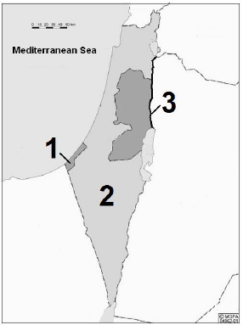
- Identify the Southwest Asian countries numbered on the map to the right. (SS7G5b)
1: ______________________________
2: ______________________________
3: ______________________________

- Identify the three major water problems in SW Asia. (SS7G6a)
- ____________________, b. __________________________, c. ________________________

- How does one country building a dam on a river affect the neighboring country’s supply of water? (SS7G6a)
________________________________________________________________________________

- How does water pollution impact irrigation and drinking water? (SS7G6a)
________________________________________________________________________________

- How does unequal access to water impact irrigation and drinking water? (SS7G6a)
________________________________________________________________________________

- Why do most people in SW Asia live close to water supplies? (SS7G7a)
________________________________________________________________________________

- Why is the population of the Sahara Desert low? (SS7G7a)
________________________________________________________________________________

- What is the main determination of where people live in SW Asia? (SS7G7a)
________________________________________________________________________________

- What is the difference between an ethnic group and a religious group? (SS7G8a)
________________________________________________________________________________
________________________________________________________________________________

- What do the ethnic groups of Arabs, Persians, and Kurds have in common? (SS7G8b)
________________________________________________________________________________
________________________________________________________________________________

- What characteristics do the religions of Judaism, Islam, and Christianity have in common? (SS7G8c)
________________________________________________________________________________
________________________________________________________________________________

- Compare and contrast the religions of Judaism and Islam in SW Asia. (Such as Sacred Building, Sacred Text, Leader, Name of God and Symbol, etc.)(SS7G8c)
________________________________________________________________________________
________________________________________________________________________________
_________________________________________________________________________

- Compare and contrast the religions of Islam and Christianity in SW Asia. (Such as Sacred Building, Sacred Text, Leader, Name of God and Symbol, etc.)(SS7G8c)
________________________________________________________________________________
________________________________________________________________________________
_________________________________________________________________________

