Skills Worksheet
Reinforcement

Building a Eukaryotic Cell
Complete this worksheet after you finish reading the section “Eukaryotic Cells.” Below is a list of the features found in eukaryotic cells. Next to each feature, write P if it is a feature found only in plant cells and a B if it is a feature that can be found in both plant and animal cells.
______ 1. endoplasmic reticulum | ______ 7. Golgi complex
______ 2. mitochondria | ______ 8. cell wall
______ 3. nucleus | ______ 9. vesicles
______ 4. cell membrane | ______10. DNA
______ 5. cytoplasm | ______11. nucleolus
______ 6. ribosomes | ______12. chloroplasts

In the space provided, label the structures of the eukaryotic cell drawn below. Include only the structures that you labeled B.
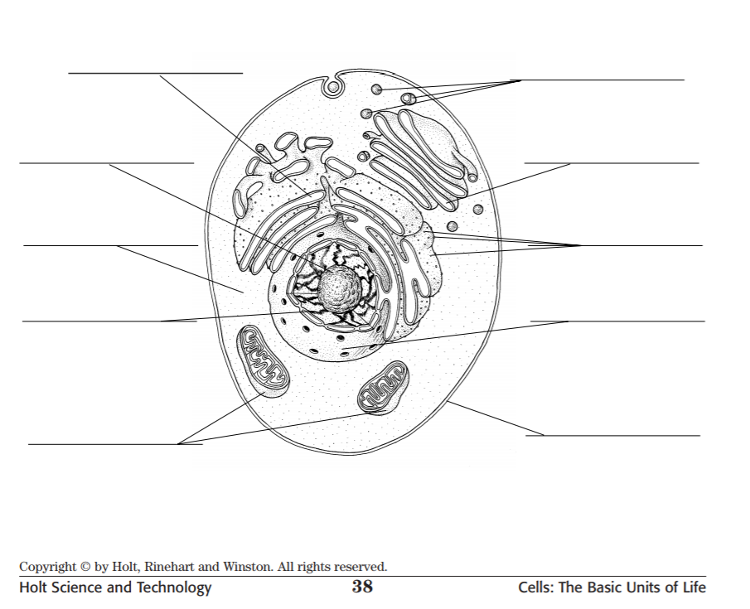
Cell Study Guide
--Directions: Use your notes to answer the following cellular organization questions.
- A group of cells with the same function make up _______________________.
- Two or more tissues make up. _____________________.
- Two or more organs make up ______________________.
- Your stomach is an example of an __________________________.
- The lowest level of cell organization is the _________________________.
- The highest level of cell organization is the ____________________________.
--Describe the various functions of the following cell organelles:
- Cell wall: ______________________________________________________________.
- Cell membrane: __________________________________________________.
- Nucleus: ________________________________________________________.
- Mitochondria: ______________________________________.
- Chloroplast: ___________________________________________.
- Ribosome: _________________________________________________.
- Lysosome: __________________________________________________.
- Endoplasmic Reticulum: ____________________________________________.
- Cytoplasm: ______________________________________________________.
- Vacuoles: _______________________________________________.
- Golgi Body: _____________________________________________________.
Answer the following:
- What are the three components of the Cell Theory?
  - ______________________________________________________________.
  - ______________________________________________________________.
  - ______________________________________________________________.
- What are the differences between bacteria and animal cells?
______________________________________________________________
______________________________________________________________.
- What are the differences between plant and animal cells? Label the parts on the animal and plant cells below.
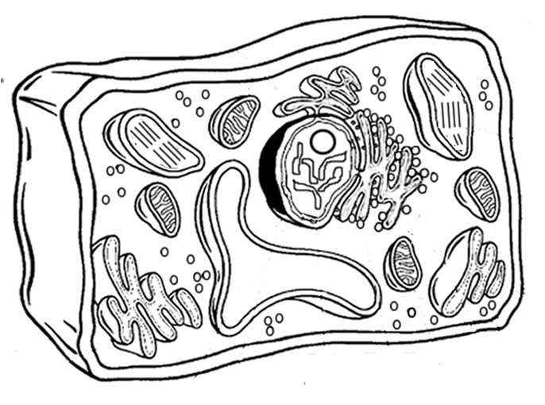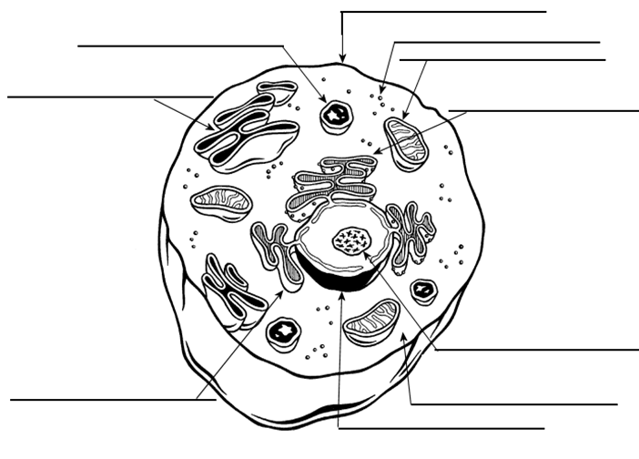
Plant Cell Animal Cell

